Title : Implement Client Script & UI Policy (Incident)
College Name :
College Code :
University Name : Manonmaniam Sundaranar University, Tirunelveli
Course Name : ServiceNow – System Admin with IT Service Management & AI Emphasis
Department : B.sc Information Technology
Team ID : SWTID-2026-2056
Team Leader : Antony Jeyakodi B
Team Member : Amala Jeba P
Team Member : Chitra M
Team Member : Kavi Priya R

Implement Client Script & UI Policy (Incident)
Introduction:
Incident records require consistent and accurate data entry for effective triage, routing, and resolution. Relying only on user awareness and manual checks can lead to incomplete, inconsistent, or incorrect information. This project demonstrates how ServiceNow UI Policies and Client Scripts can control field behavior, enforce mandatory values, automate updates, and validate Incident records before submission.
The implementation uses UI Policy Actions together with onChange, onSubmit, and onCellEdit Client Scripts. The configuration dynamically responds to the Impact field, controls the Urgency field, validates Assigned To, and prevents direct State changes through list editing.

Problem Statement
Incident records often require consistent and accurate data entry to ensure effective triage, routing, and resolution. However, relying solely on user awareness and manual checks can lead to incomplete, inconsistent, or incorrect data being submitted. This can impact reporting accuracy, SLA compliance, and overall service quality. To address this challenge, conditional field behavior and validation are enforced directly at the user interface level.

Objective
The objective of the Implement Client Script & UI Policy (Incident) project is to demonstrate how ServiceNow client-side controls can be used to enforce data integrity on Incident records. The implementation dynamically makes fields mandatory, auto-populates values, controls field behavior, and prevents record submission when required conditions are not met.

Skills
Incident Management
UI Policy
UI Policy Actions
Client Scripts
Form Validation

Milestone 1: Create UI Policy on Incident

Activity 1: Create UI Policy
1. Log in to the ServiceNow instance with administrative or configuration access.
2. Navigate to System UI → UI Policies.
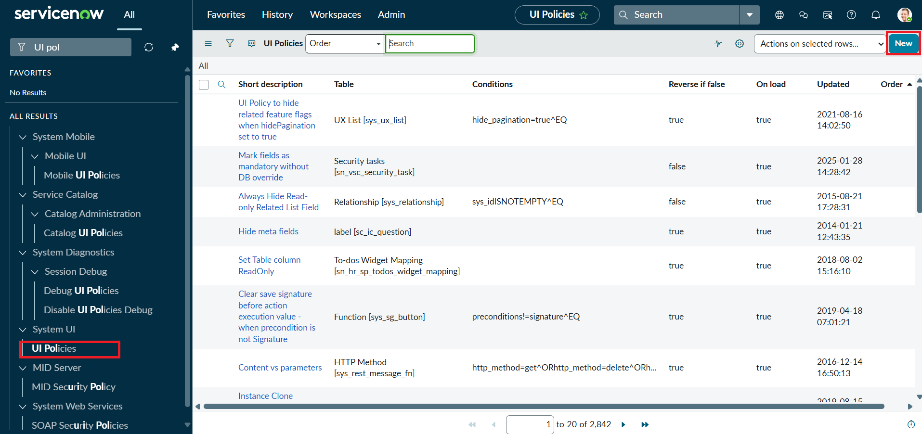
Screenshot 1: Navigating to UI Policies.
3. Click New to create a new UI Policy record.
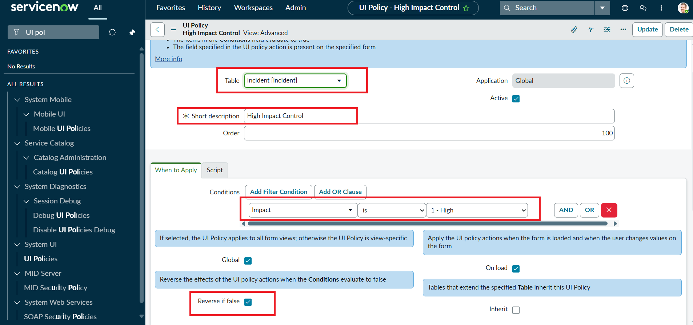
Screenshot 2: Creating the High Impact Control UI Policy.
Fill in the following details:
• Name: High Impact Control
• Table: Incident
• Active: true
4. Configure the Conditions section: Field = Impact, Operator = is, Value = 1 – High.
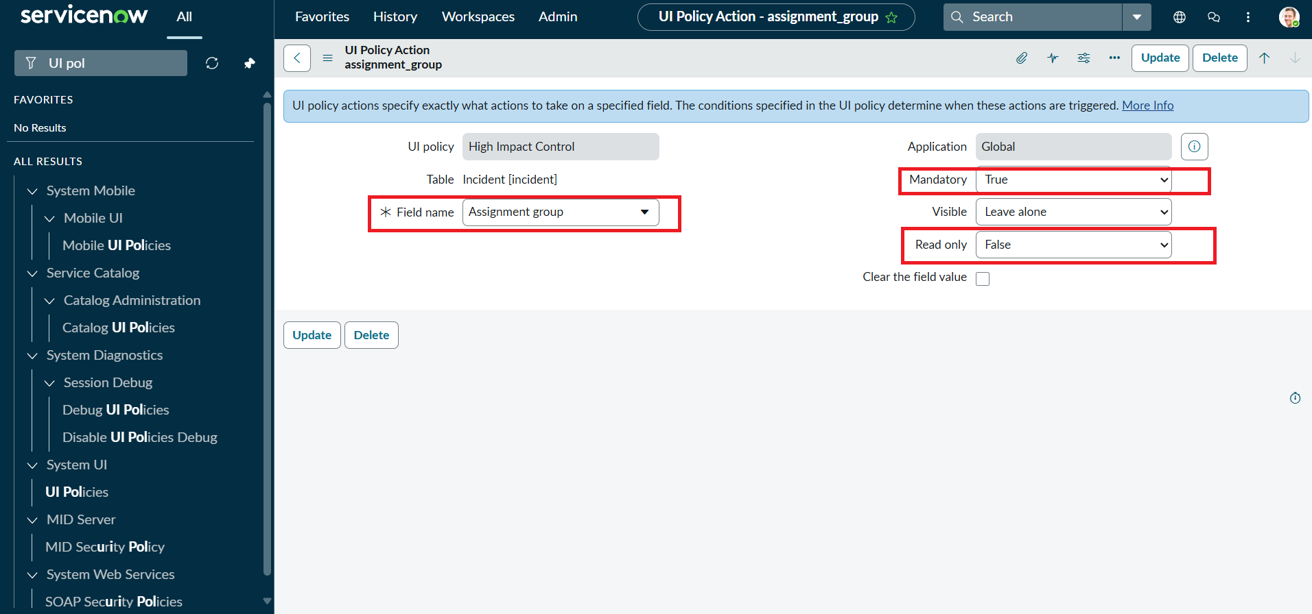
Screenshot 3: Configuring the Impact = 1 – High condition.
5. Configure the UI Policy Action for Assignment group and check Mandatory.
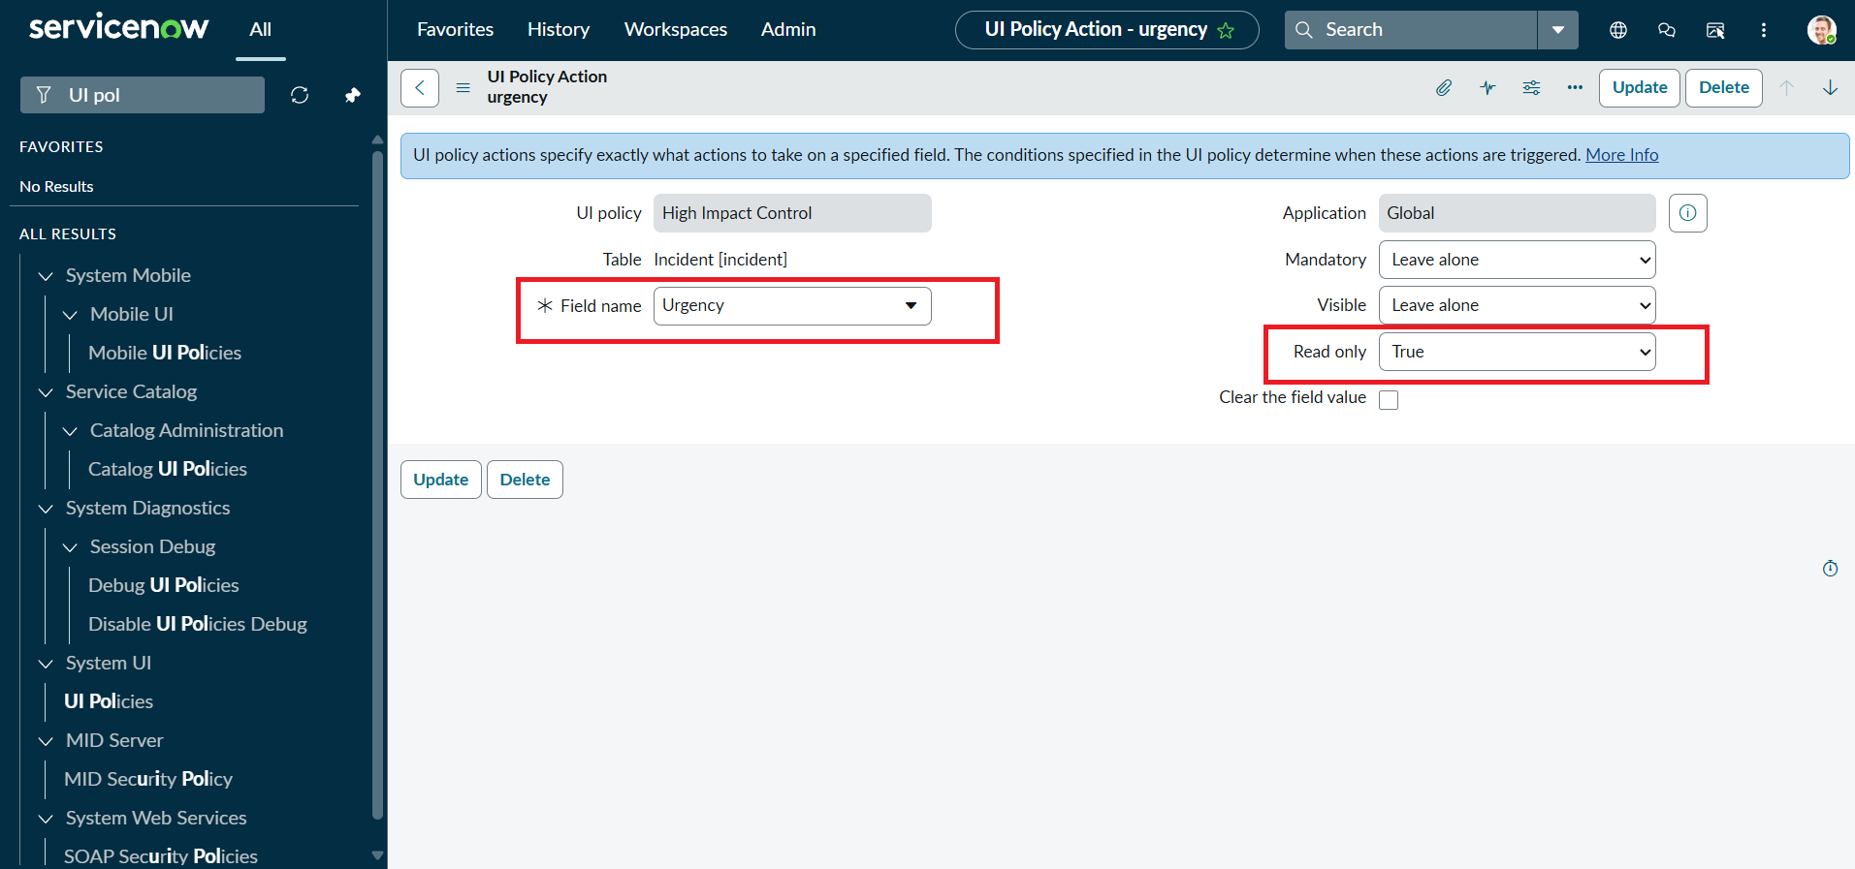
Screenshot 4: Making Assignment group mandatory.
6. Set Reverse if false to true. This reverses the field changes when the condition is no longer true.
7. Review the configuration and click Submit to save the UI Policy.

Milestone 2: Create UI Policy Action – Urgency

Activity 1: Configure the Urgency Field
1. Open the High Impact Control UI Policy and scroll to the UI Policy Actions related list.
2. Click New to create a UI Policy Action.
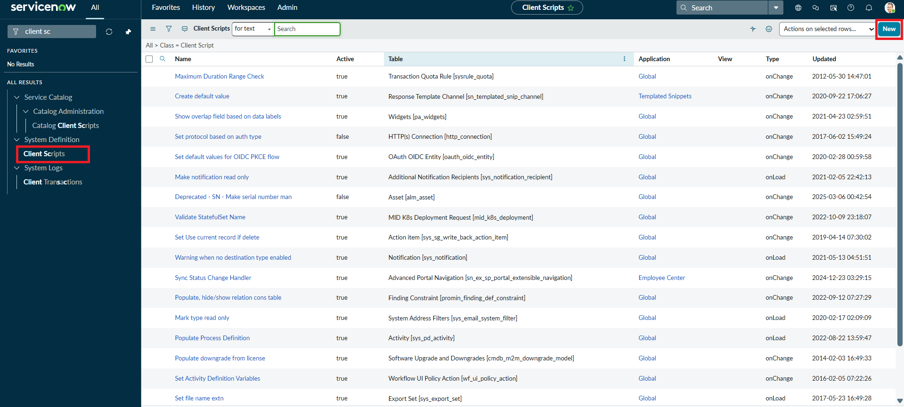
Screenshot 5: Opening the UI Policy Actions list.
3. Set Field name = Urgency, Read-only = true, and leave Visible unchanged.
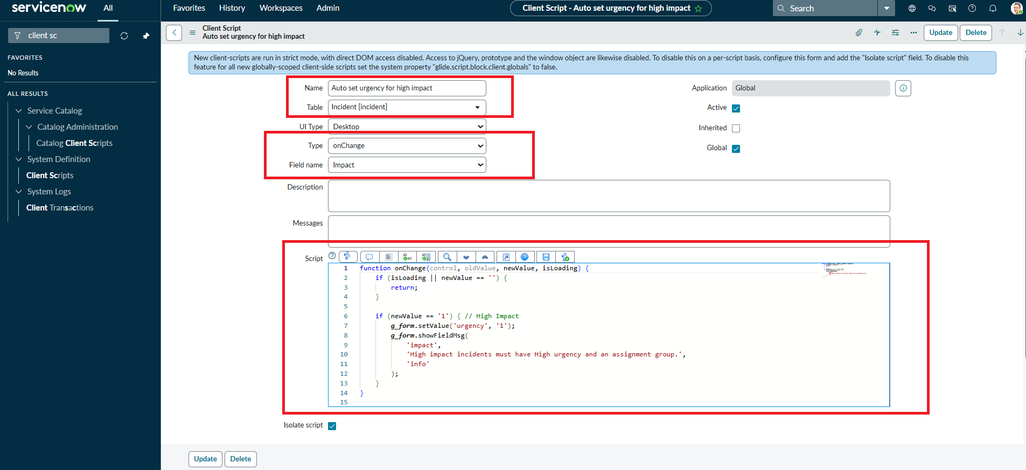
Screenshot 6: Configuring the Urgency UI Policy Action.
4. Click Submit to save the action.
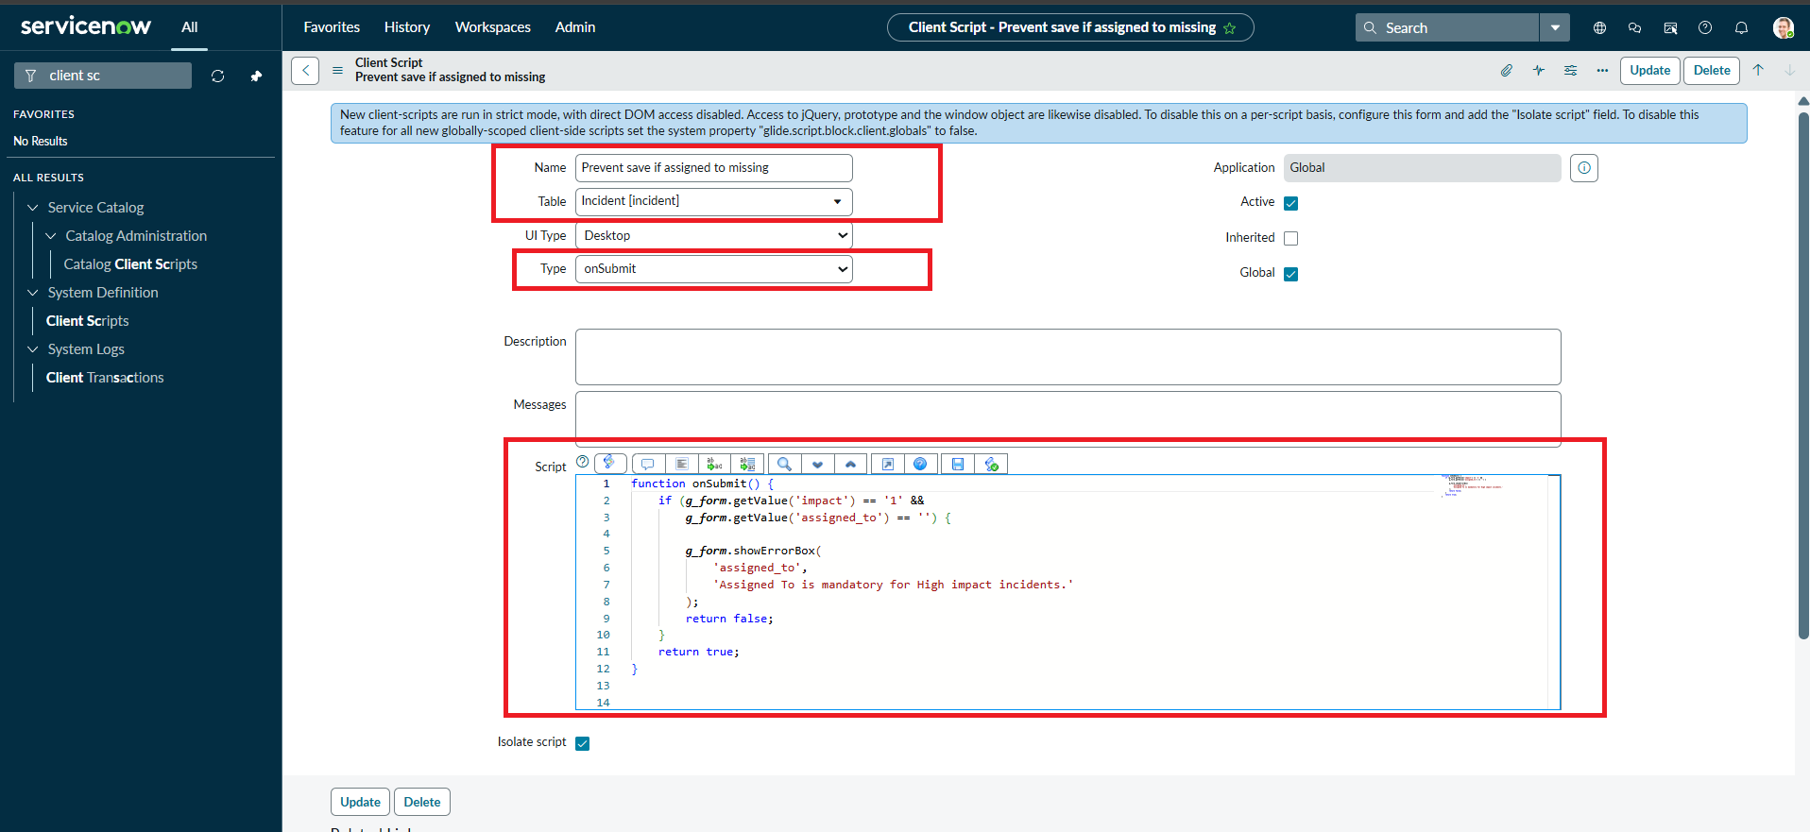
Screenshot 7: Saving the Urgency UI Policy Action.
5. Verify by opening an Incident, setting Impact to High, and confirming that Urgency becomes read-only.

Milestone 3: Create onChange Client Script

Activity 1: Create Client Script
1. Navigate to System UI → Client Scripts.
2. Click New to create a new Client Script.
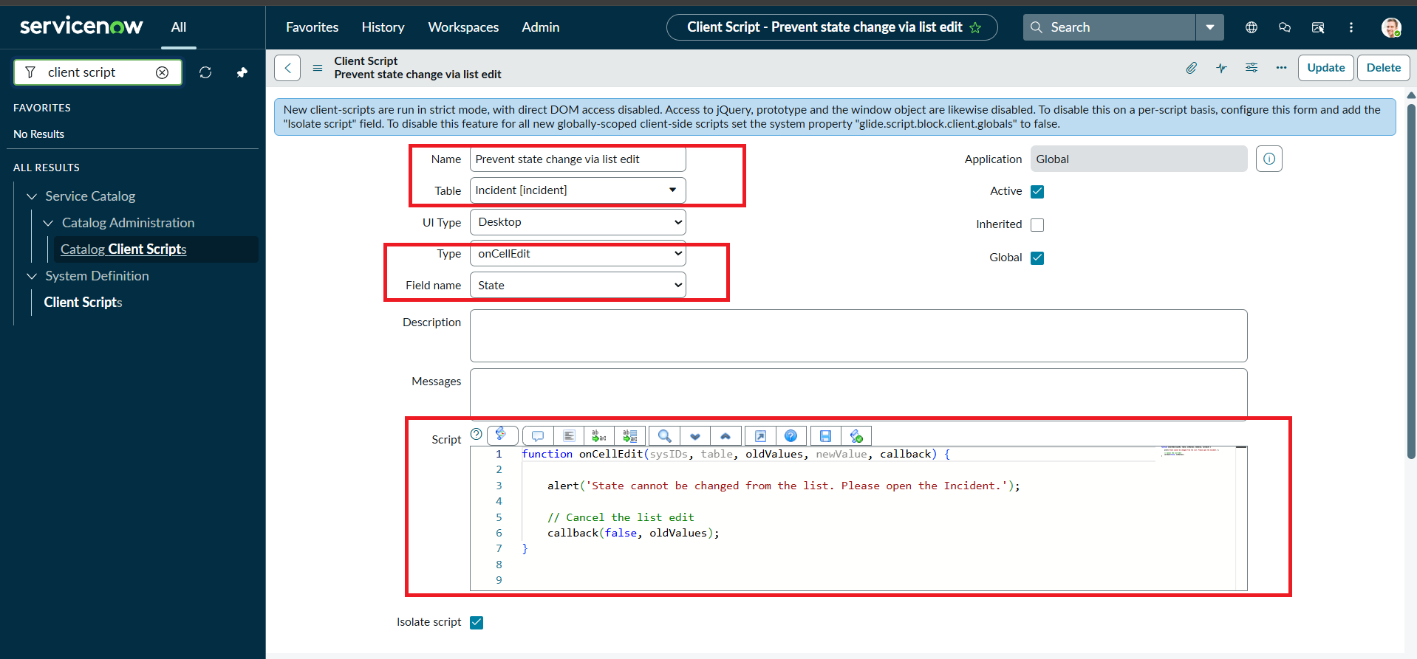
Screenshot 8: Creating the onChange Client Script.
Fill in the details:
• Name: Auto set urgency for high impact
• Table: Incident
• Type: onChange
• Field name: Impact
• Active: true
3. Paste the following script into the Script field:
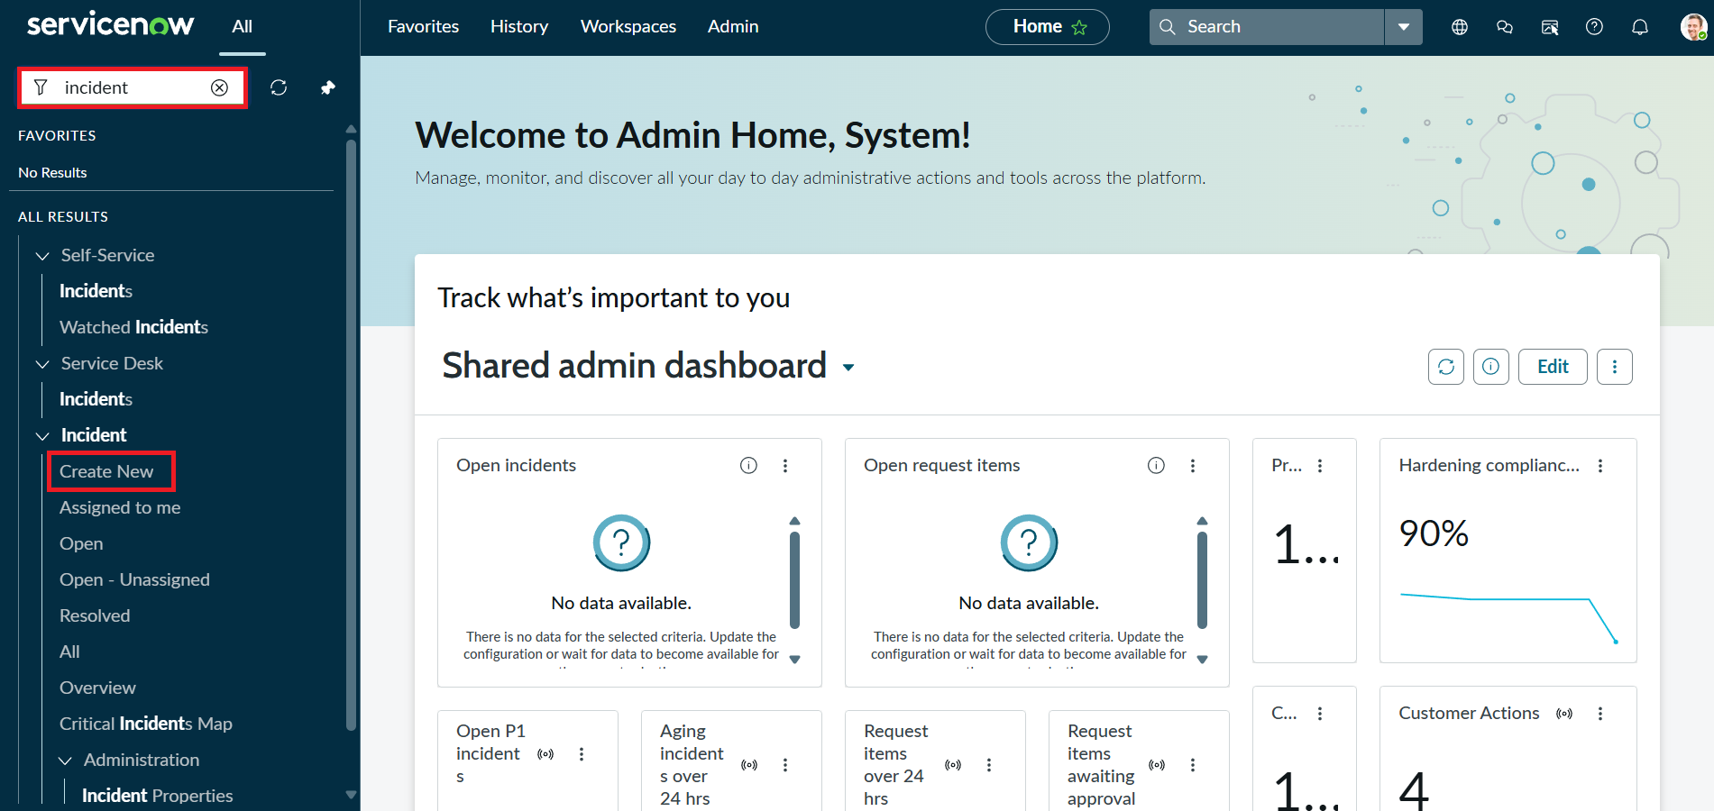
Screenshot 9: Client Script editor and script configuration.
4. Click Submit to save the Client Script.
5. Verify by opening an Incident and changing Impact to High. The Urgency field should update automatically.

Milestone 4: Create onSubmit Client Script – Save Validation

Activity 1: Create Client Script
1. Navigate to System UI → Client Scripts and click New.
2. Fill in Name = Prevent save if Assigned To missing, Table = Incident, Type = onSubmit, and Active = true.
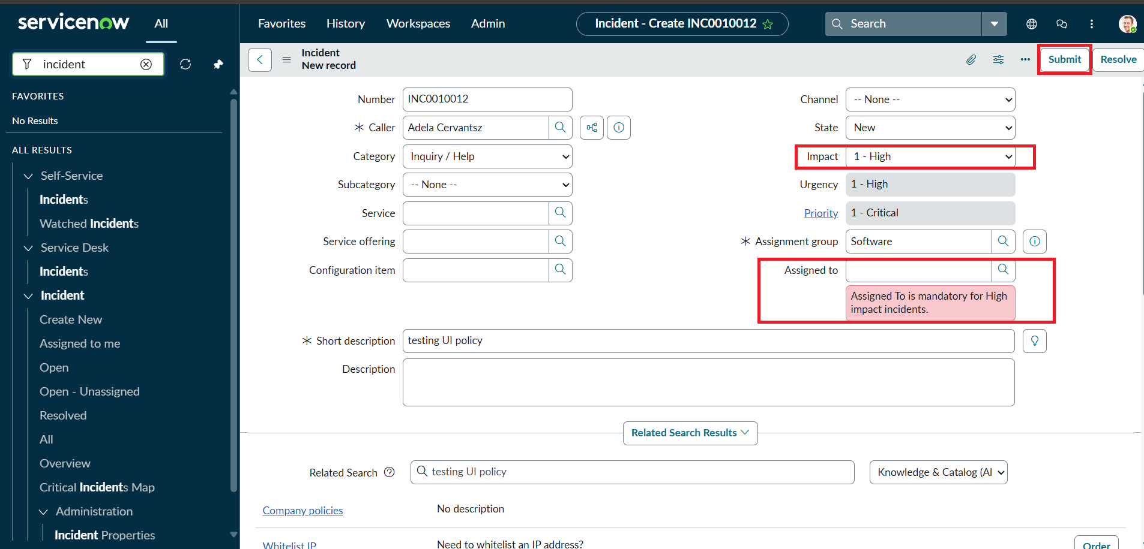
Screenshot 10: Configuring the onSubmit Client Script.
3. Paste the following script into the Script field:
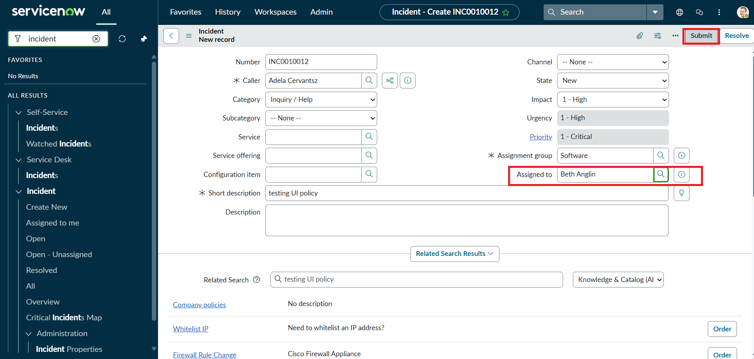
Screenshot 11: onSubmit Client Script configuration.
4. Click Submit to save the Client Script.
5. Verify by trying to save an Incident with Impact = High and Assigned To empty. The save should be prevented and a warning should appear.

Milestone 5: Create onCellEdit Client Script

Activity 1: Create Client Script
1. Navigate to System UI → Client Scripts and click New.
2. Fill in Name = Prevent state change via list edit, Table = Incident, Type = onCellEdit, Field name = State, and Active = true.
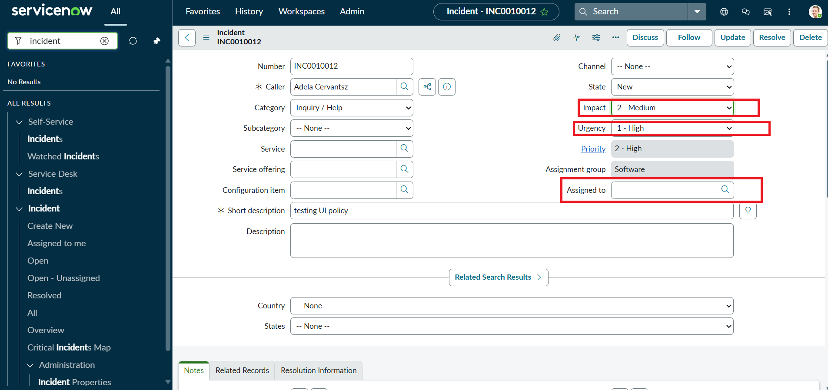
Screenshot 12: Configuring the onCellEdit Client Script.
3. Paste the following code into the Script field:
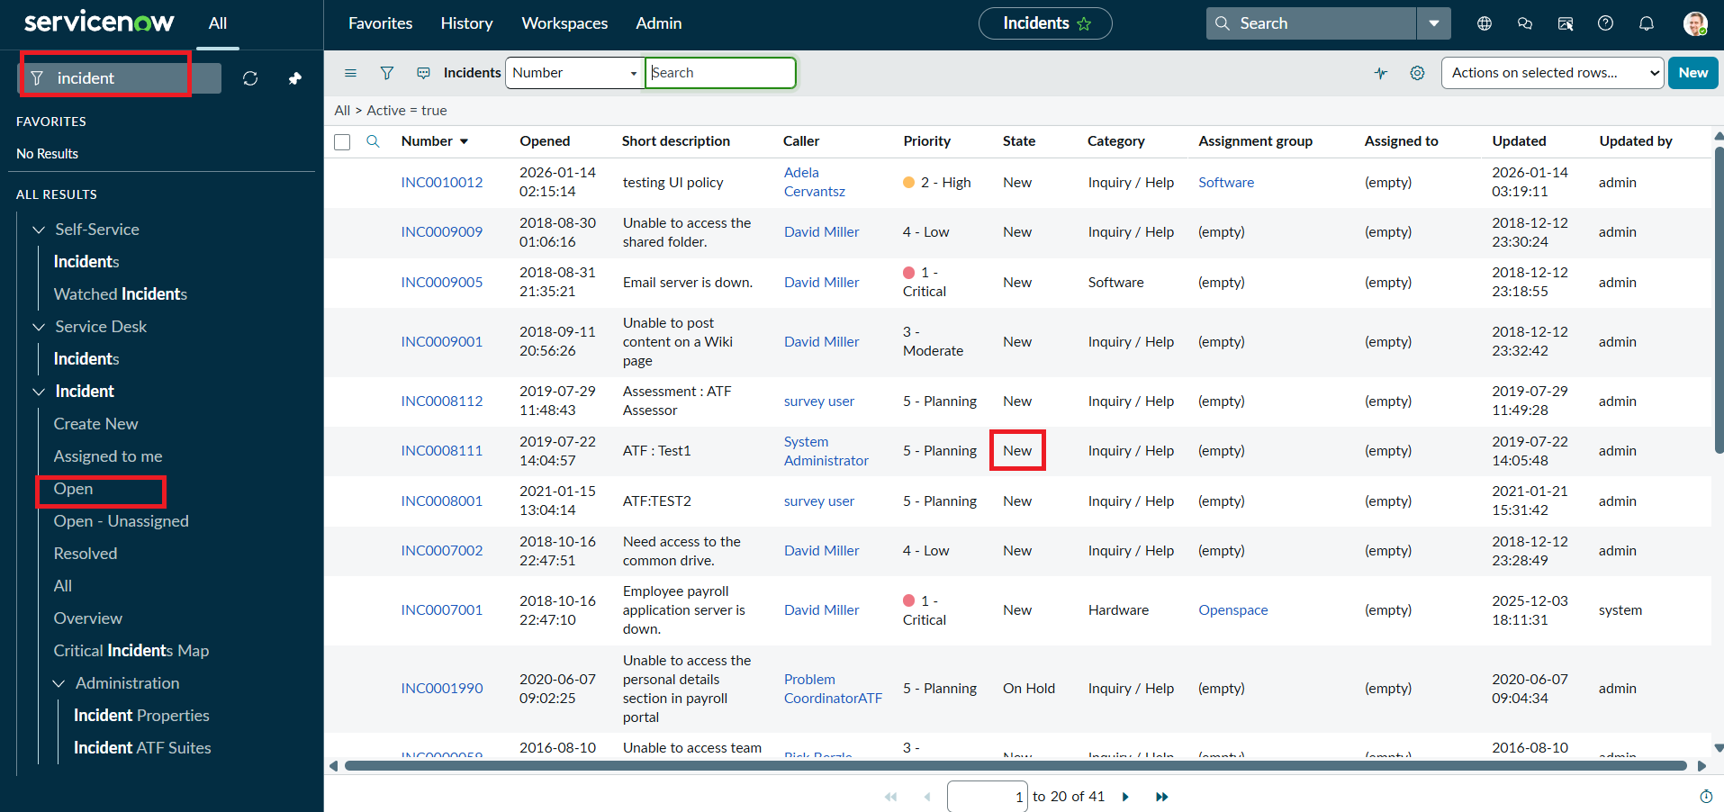
Screenshot 13: onCellEdit Client Script.
4. Click Submit to save the Client Script.
5. Verify by opening an Incident list and trying to change the State field directly in the list.

Milestone 6: Testing the Configuration

Activity 1: Test Mandatory Enforcement
1. Navigate to Incident → Create New to open a new Incident form.
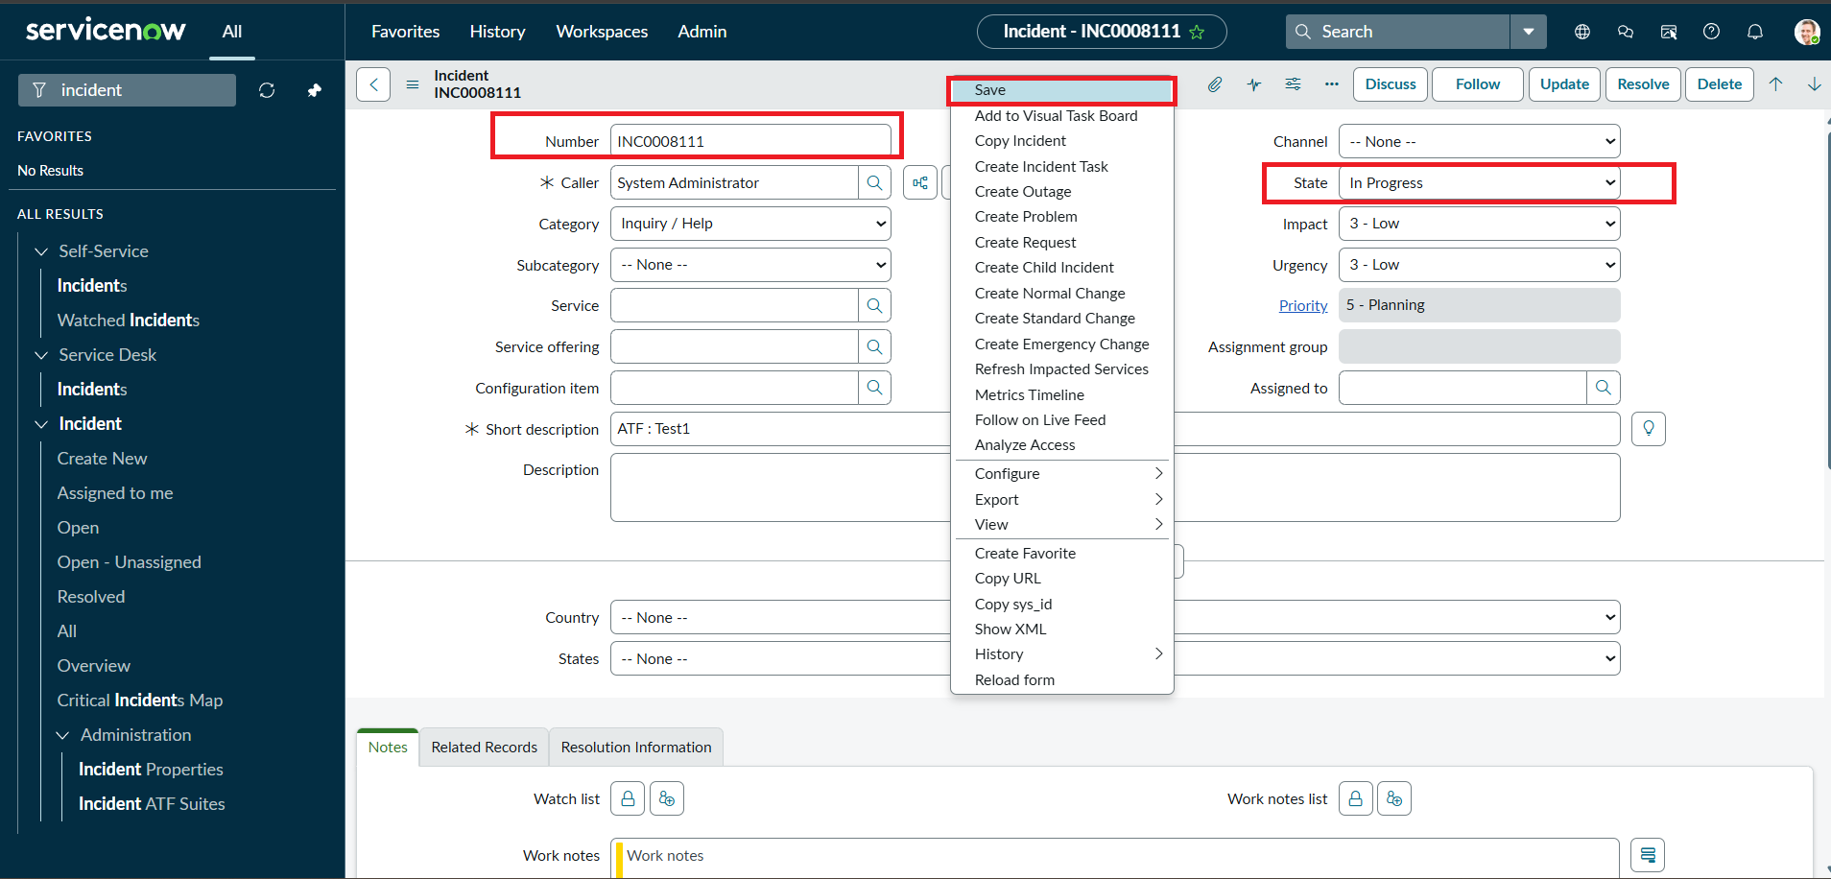
Screenshot 14: Incident form used for testing.
2. Set Impact to High and leave Assigned To empty.
3. Click Submit and verify that the Incident is not saved because Assigned To is required.
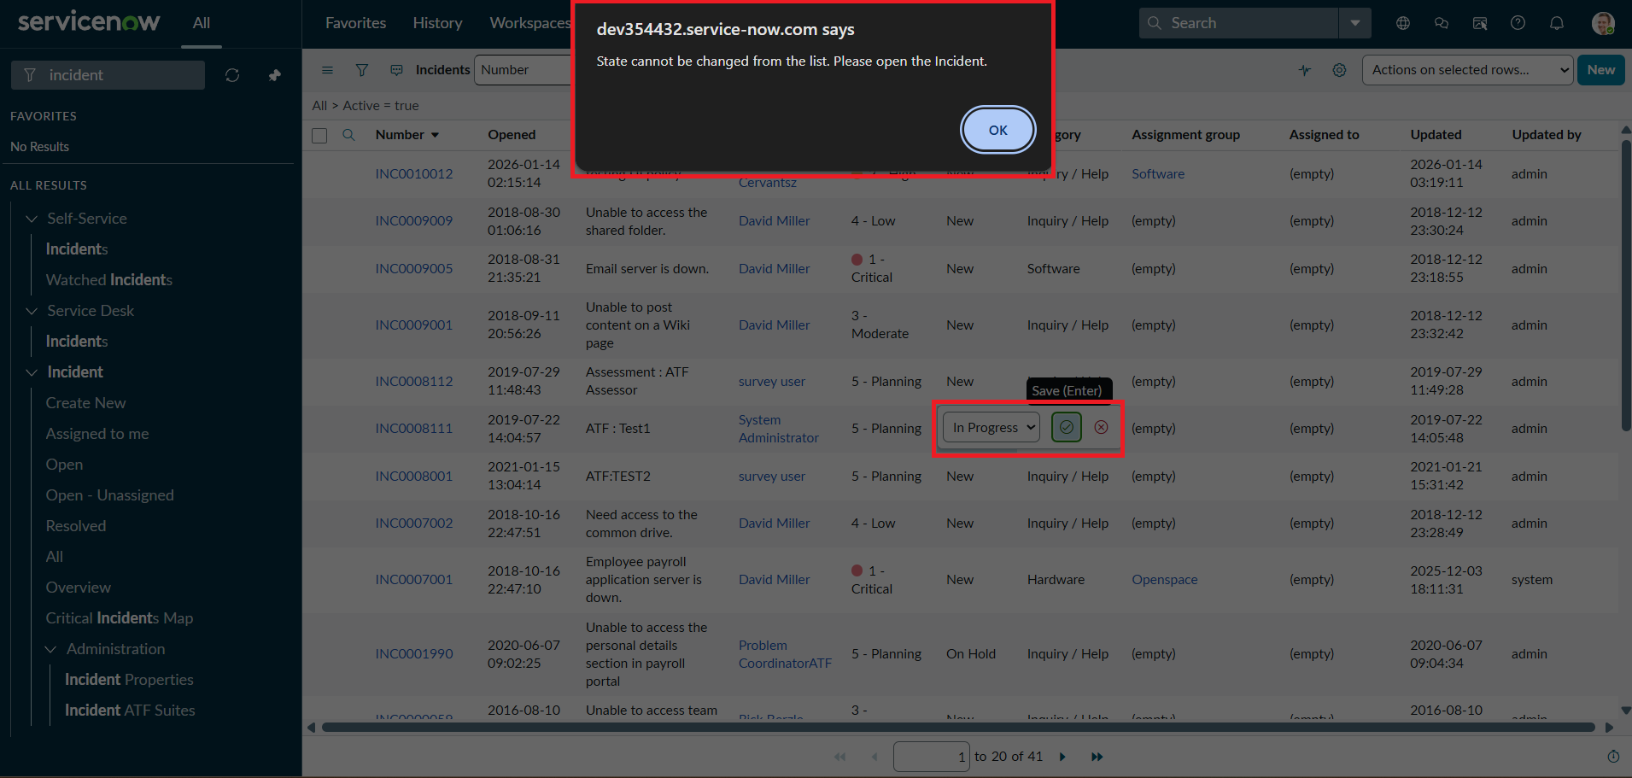
Screenshot 15: Validation message shown when Assigned To is missing.
4. Confirm that the UI Policy and Client Script behaviors are working as configured.

Activity 2: Test Successful Save
1. Open the Incident form and select a user in the Assigned To field.
2. Click Submit and verify that the Incident is saved successfully.
3. Confirm Urgency auto-setting, read-only behavior, and State restrictions.

Activity 3: Reverse Condition Test
1. Open an existing Incident where Impact is High.
2. Change Impact from High to Medium.
3. Verify that Assigned To is no longer mandatory and Urgency becomes editable.
4. Click Submit to save the record.

Activity 4: Test List Edit Blocking
1. Navigate to Incident → All to view Incident records.
2. Double-click the State field and attempt to edit it directly from the list.
3. Verify that the alert appears and the State value remains unchanged.
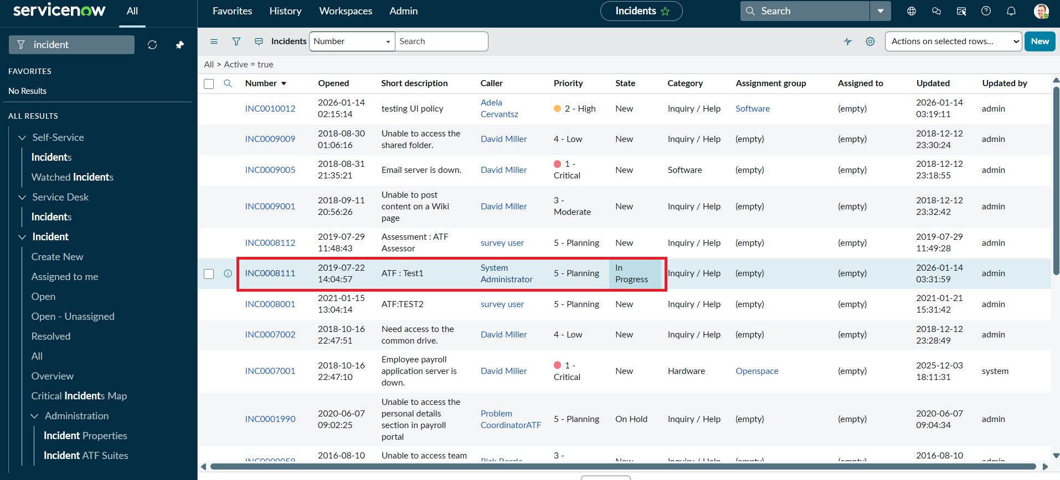
Screenshot 16: Incident list used to verify list-edit behavior.

Activity 5: Test Form-Based Update
1. Open the same Incident record.
2. Change the State field on the Incident form.
3. Click Update.
4. Verify that the State change is saved successfully and other UI Policy/Client Script rules remain active.

Outcome
The configuration demonstrates the combined use of UI Policies and Client Scripts on the Incident form. The High Impact Control UI Policy makes Assignment group mandatory for high-impact incidents and controls the Urgency field. The onChange Client Script automatically sets Urgency to High, the onSubmit Client Script validates Assigned To before saving, and the onCellEdit Client Script blocks direct State changes through list editing.

Advantages
- Improves data consistency on Incident records.
- Enforces mandatory fields based on business conditions.
- Automatically updates field values when Impact changes.
- Prevents invalid or incomplete Incident submission.
- Controls list editing of sensitive fields such as State.
- Provides dynamic form behavior without requiring a full page submission.

Disadvantages
- Incorrect Client Script conditions can affect Incident form behavior.
- Multiple UI Policies and Client Scripts can become difficult to maintain.
- Changes in business requirements may require script updates.
- Client-side controls should be tested carefully to avoid unexpected user experience issues.

Future Enhancement
The project can be enhanced by adding additional validation rules, role-based field controls, reusable Script Includes, automated testing with ServiceNow ATF, and more detailed user guidance messages. Additional UI Policies can also be introduced for different Impact, Urgency, and Assignment conditions as business requirements evolve.

Conclusion
The Implement Client Script & UI Policy (Incident) micro project demonstrates how ServiceNow client-side controls can enforce dynamic field behavior, automate updates, and prevent incorrect data submission. By using UI Policy Actions together with onChange, onSubmit, and onCellEdit Client Scripts, the project helps maintain complete and consistent Incident information while improving form usability and data integrity.

